TECHNICAL UNIVERSITY OF KOSICE
FACULTY OF MINING, ECOLOGY, PROCESS CONTROL AND GEOTECHNOLOGIES
WRITTEN PREPARATION IN A FOREIGN LANGUAGE WITHIN THE DOCTORAL STUDIES
Professional foreign language for doctoral students
DISSERTATION TOPIC:
Study programme: | Name of the study program (see individual study plan)
Field of the study: | Name of the field of the study (see individual study plan)
Training center: | Name of the Institute
Dissertation supervisor: | Degree Name Surname, Degree
2023 Košice | Name Surname, Degree

Abstract
Text of the abstract in a world language.

Keywords
Key word 1, Key word 2, Key word 3, Key word 4, ...

Contents
List of Figures 4
List of Tables 5
Introduction 6
1. Task Formulation and the Dissertation Objective 7
2. Theoretical Analysis of the Topic 8
3. Analysis of the Current State 9
4. Design and implementation of Solutions to Selected Issues 10
4.1. How to insert Pictures into a Document 10
4.2. How to insert Tables into a Document 11
4.3. How to insert Graphs into a Document 12
4.4. Citing from References and the List of References 13
5. Procedure for Submitting the Written Preparation in a Foreign Language within the Doctoral Studies 15
Conclusion 16
References 17

List of Figures
Fig. 1 Inserting a Picture caption 11
Fig. 2 Inserting a Table caption 12
Fig. 3 Comparison of the percentage of similarity at faculties for bachelor studies in 2013 13

List of Tables
Tab. 1 Statistical evaluation of the percentage of similarity for 2013 12

Introduction
Brief and clear introduction (min. 1 page).
- expresses the state of knowledge or practice in the given area,
- justifies the topicality of the chosen topic,
- raises problems that are to be solved,
- explains the purpose and objectives of the work,
- describes the methods used and solution procedure,
- states the relation of the work to other works in the given area, specifies the information sources and sources which author used the most (and which he/she shall state in the list of bibliographical references),
- justifies the importance of solving the problem,
- outlines the brief content of the chapters.

- Task Formulation and the Dissertation Objective
In this chapter, author explains the way in which the tasks and theses, which will be formulated in the dissertation assignment, will be solved. They will also provide an overview of conditions of the solution. If the formulation of the task is not necessary, a different title of this chapter (Title of Chapter 1) will be used according to the problem to be solved.
- Theoretical Analysis of the Topic
This chapter usually represents the theoretical and methodological part of the dissertation. This section usually contains:
- theoretical knowledge related to the given task (the student presents knowledge acquired during the study),
- a description of the technologies used during problem solving,
- a comparison with other technologies and methods,
- reasons why a certain method was chosen, etc.

This chapter should normally account for one third of the total number of pages, and we consider it as a theoretical part of the dissertation.

- Analysis of the Current State
This chapter discusses the current state of the problem that we solve in the dissertation. These are various initial states, input values, current output values, operating conditions, data model, current calculation, carrier formulas and conversions of values and variables.
Thus, it is a detailed description of the researched topic, all its partial parts, and a description of individual flows of information between parts of the system, enterprise, business, application, and the like.
Furthermore, it is possible to describe what functional means were chosen to achieve the solution of the problem, but in the current or actual system.

- Design and implementation of Solutions to Selected Issues
This chapter is the core of the dissertation, and its scope should account for one third of the total number of pages.
Based on the knowledge from previous chapters, this chapter should contain its own proposal for solving the problem or system.
Thus, it is necessary to propose solutions to partial problems such as:
- behavior model of business, or application,
- internal information flows,
- in the case of information systems, it should include a database model, user case diagram and the like,
- as well as a general description of how the assignment will be solved.
In the dissertation, it is possible to use various formulas, figures, tables, but also cross-references to literature or web content, and a list of references at the end.
How to work with modern functions in WORD 2013 (compatible with Word 2007-Word 2010 functions) will be shown in the following chapters.

  - How to insert Pictures into a Document
When inserting pictures, use the tab in the top bar INSERT -> PICTURE. Then a window for selecting a PC file will appear, after which the picture will be inserted automatically. It is also possible to insert a picture using CTRL-C and CTRL-V, for example, from a web page or other document.
The description of the picture is inserted automatically via the tab REFERENCES -> INSERT CAPTION. A window will appear where you can choose whether you want to insert caption for a table or a figure.
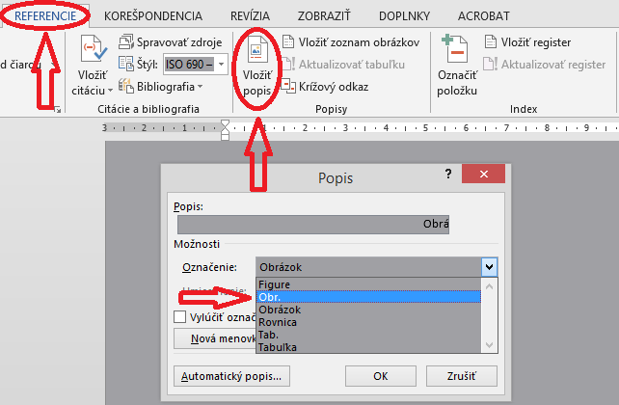
Fig. 1 Inserting a Picture caption

In this template, the abbreviation Fig. with the corresponding number is used. If the full name “Figure” is selected, then a list of figures will not be generated at the beginning of the dissertation, because this field is not defined in it. It is therefore necessary to use the abbreviation Fig.

  - How to insert Tables into a Document
A table can be used for various selections, subdivisions, value entries, or matrix entries. The graphic design is not prescribed, so any theme can be used. The description of a table is inserted in a similar way as the description of the pictures, with the only difference that we have to select the item Tab. from the drop-down menu. You can find this menu as with the figures, REFERENCES -> INSERT CAPTION. When the window appears, select the Tab. option and press OK.
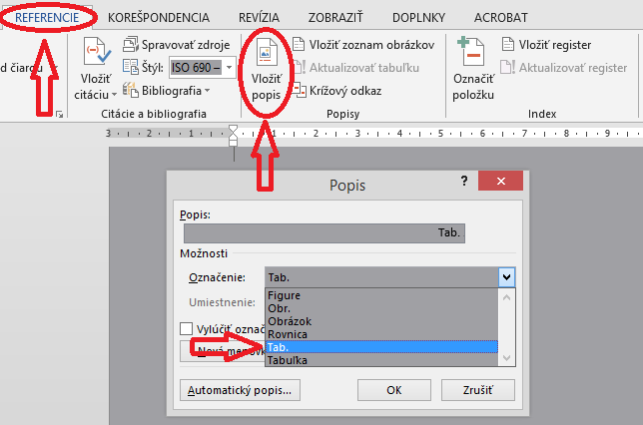
Fig. 2 Inserting a Table caption

Tab. 1 Statistical evaluation of the percentage of similarity for 2013
% similarity | FBERG |  |  | HF |  |  | SJF |  |  | FEI |  |  | SVF |  |  | FVT |  |  | EKF |  |  | FU |  |  | LF
 | BC | ING | PHD | BC | ING | PHD | BC | ING | PHD | BC | ING | PHD | BC | ING | PHD | BC | ING | PHD | BC | ING | PHD | BC | ING | PHD | BC | ING | PHD
0 - 10% | 281 | 321 | 27 | 110 | 54 | 27 | 377 | 359 | 28 | 431 | 382 | 23 | 93 | 94 | 24 | 150 | 168 | 8 | 181 | 173 | 14 | 39 | 27 |  | 85 | 200 | 4
11 - 20% | 55 | 78 | 5 | 12 | 14 | 1 | 37 | 72 | 3 | 17 | 31 |  | 35 | 32 | 3 | 33 | 51 | 1 | 24 | 19 |  | 1 | 3 |  | 22 | 30 | 1
21 - 30% | 26 | 40 | 4 | 6 | 8 |  | 21 | 24 | 1 | 6 | 11 |  | 16 | 15 | 1 | 19 | 31 | 2 | 4 | 4 | 1 | 2 | 1 |  | 7 | 20 | 1
31 - 40% | 10 | 20 |  | 1 | 2 |  | 7 | 9 |  | 5 | 2 |  | 6 | 10 |  | 7 | 13 | 1 |  | 1 |  |  |  |  | 2 | 13
41 - 50% | 14 | 10 |  |  |  |  | 4 | 1 |  | 1 | 1 |  | 4 | 3 |  |  | 3 |  |  |  |  |  |  |  | 1 | 7
51 - 60% | 2 | 1 | 1 | 2 |  |  | 4 | 2 |  | 3 |  |  | 1 |  |  | 2 | 2 |  | 2 | 2 |  |  |  |  | 2 | 2
61 - 70% | 1 | 1 |  |  |  |  | 5 |  |  | 3 |  |  |  |  |  |  |  |  |  | 1

  - How to insert Graphs into a Document
If you need to insert a chart, you can copy the chart from Excel and paste it into the document, or via the INSERT -> CHART menu, after which a data entry window will open and the chart will be generated from this data immediately. The description of the graph is entered in a same way as the description of a picture.

Fig. 3 Comparison of the percentage of similarity at faculties for bachelor studies in 2013

  - Citing from References and the List of References
When writing a dissertation, we often draw on the experience and research of other teams. Parts of the text, definitions, axioms, rules, laws, and various theories described in the books must be properly cited. The ethics of acknowledging a cited source is also enshrined in a law that defines terms such as plagiarism. Plagiarism is the illegal use of somebody else's published and unpublished ideas, formulations, knowledge, research results or other results of creative work, as well as illustrations, tables, photographs, etc. without reference (proper reference to the original source of information). The first step is to select the literature and create a list for your own use, which will later serve as an official list of references. In order to avoid plagiarism, it is necessary to cite all the information, taken from other sources, in the document correctly. We recognize two types of citing; we can use Quotation or Paraphrase:
Quotation:
is a text taken from some source word for word. We write it in quotation marks, or we can signal it by changing the font + source number in square brackets at the end of the quote.
Paraphrase:
free adaptation, free interpretation, expression of the same content in other words or means. It is sufficient to state the source number in square brackets at the end of the paraphrase.
This text is from the source:
Veľký slovník cudzích slov online [online]. [s.a.]. [cit 2023-03-19]. Available online: <http//www.cudzieslova.sk/>.

Citation in accordance with STN ISO 690:
We recognize:
- Numerical reference – RECOMMENDED
- Method of in-text citations (footnotes)
- First element and date method

Numerical reference
Citations are associated with the description of the cited document by the order number in brackets. The order of the references corresponds to the first occurrence of their citation. If several citations of the same document follow, they have the same number as the first citation. If specific parts of the document are cited, page numbers may be given after the citation number. References in the numbered list of bibliographic references are arranged according to their order numbers.
The list of bibliographical references is located at the end of the chapter or at the end of the entire text (book, article, etc.) and is arranged according to the order numbers of the references as the citations are numbered in the text. The order numbers of references are located on the left and the reference details are indented.
This text is from the source:
KIMLIČKA, Štefan: Príklady citovania podľa ISO 690 a ISO 690-2. [online]. Bratislava: Katedra knižničnej a informačnej vedy FiFUK, 2004. [cit 2023-03-19]. Available online: <http://vili.uniba.sk/AK/citovanie_priklady.pdf>.

- Procedure for Submitting the Written Preparation in a Foreign Language within the Doctoral Studies
The prepared “Written Preparation in a Foreign Language within the Doctoral Studies” must be delivered in electronic form (docx or pdf) to the Department for Scientific - Research Activities and Foreign Relations and Education in III. level of University Study of the Faculty of Mining, Ecology, Process Control and Geotechnologies, no later than 5 days before the exam.

Conclusion
The conclusion should capture a clear and accurate presentation of the deductions based on the core of the dissertation. It must be a factual summary of one's own contribution or view of the problem being solved. Quantitative data may be included, but details should not be provided. The conclusion should not contain anything that is not in the text of the dissertation and must follow the considerations and arguments in the text of the dissertation.
In conclusion, it is appropriate to point out other open (so far unresolved) problems, which should be paid attention to and which exceed the recommended scope of the final dissertation. Descriptions of other proposed activities are recommended, which directly result from the conclusions or experience gained during working on the dissertation.

References
- Tomášová, Viera; Štocková, Zuzana. Ako správne citovať. Záverečné práce. [Online] Technická univerzita v Košiciach, 03. 03 2014. [Date: 03. 03 2014.] http://www.lib.tuke.sk/wwwroot/doc/Navody/CIT.ppt.
- ISO 690-2: 1997, Information and documentation – Bibliographic references - Part 2: Electronic documents or parts thereof.
- STN ISO 690:1998 : Dokumentácia - Bibliografické odkazy - Obsah, forma a štruktúra.
- Zákon č. 183/2000 Z.z. o knižniciach, o doplnení zákona Slovenskej národnej rady č. 27/1987 Zb. o štátnej pamiatkovej starostlivosti a o zmene a doplnení zákona č. 68/1997 Z.z. o Matici slovenskej.
- Vyhláška č. 131/1997 Zb. Ministerstva školstva Slovenskej republiky zo 7. mája 1997 o doktorandskom štúdiu.
- LAGOZE, C. et al. The Open Archives Initiative Protocol for Metadata Harvesting [online]. Protocol Version 2.0 of 2002-06-14. Document Version 2004/10/12T15:31:00Z 2004 [cit. 2004-11-10]. Available online:
<http://www.openarchives.org/OAI/openarchivesprotocol.html>.

