Technical University of Košice

Faculty of Mining, Ecology, Process Control
and Geotechnologies

Student Scientific Conference

Section S1 - Earth Sciences

Názov práce v slovenskom jazyku

Title of the work in the English language

Name and surname, degree: Ján Mrkvička, B.Sc. (Bc.)
Level of study: I. - Bachelor degree / II. - Master degree
Year of study: 3. / 2.
Study programme: Engineering Surveying and Real Estate Register
Supervisor of the work: assoc. prof. František Uholný, MSc., PhD.
!!! Please fill in the red text!!!
Contents
ABSTRAKT 3
ABSTRACT 3
1 Introduction (Heading level 1) 4

1.1 Heading level 2 4
1.1.1 Heading level 3 4

1.2 Figures 4

1.3 Tables 5

1.4 Example of equation numbering 5
References 5

ABSTRAKT
Text in the mother tongue.
Lorem ipsum dolor sit amet, consectetuer adipiscing elit. Praesent id justo in neque elementum ultrices. Morbi leo mi, nonummy eget tristique non, rhoncus non leo. Phasellus enim erat, vestibulum vel, aliquam a, posuere eu, velit. Aliquam id dolor. Ut enim ad minima veniam, quis nostrum exercitationem ullam corporis suscipit laboriosam, nisi ut aliquid ex ea commodi consequatur? Praesent dapibus. Nullam faucibus mi quis velit. Phasellus faucibus molestie nisl. Suspendisse sagittis ultrices augue. Aliquam erat volutpat. Maecenas aliquet accumsan leo. Integer tempor. Cras elementum. Cum sociis natoque penatibus et magnis dis parturient montes, nascetur ridiculus mus. Suspendisse sagittis ultrices augue. Donec quis nibh at felis congue commodo. Curabitur ligula sapien, pulvinar a vestibulum quis, facilisis vel sapien.
Kľúčové slova:
ABSTRACT
Text in the English language
Lorem ipsum dolor sit amet, consectetuer adipiscing elit. Praesent id justo in neque elementum ultrices. Morbi leo mi, nonummy eget tristique non, rhoncus non leo. Phasellus enim erat, vestibulum vel, aliquam a, posuere eu, velit. Aliquam id dolor. Ut enim ad minima veniam, quis nostrum exercitationem ullam corporis suscipit laboriosam, nisi ut aliquid ex ea commodi consequatur? Praesent dapibus. Nullam faucibus mi quis velit. Phasellus faucibus molestie nisl. Suspendisse sagittis ultrices augue. Aliquam erat volutpat. Maecenas aliquet accumsan leo. Integer tempor. Cras elementum. Cum sociis natoque penatibus et magnis dis parturient montes, nascetur ridiculus mus. Suspendisse sagittis ultrices augue. Donec quis nibh at felis congue commodo. Curabitur ligula sapien, pulvinar a vestibulum quis, facilisis vel sapien.
Keywords:

Introduction (Heading level 1)
Lorem ipsum dolor sit amet, consectetuer adipiscing elit. Praesent id justo in neque elementum ultrices. Morbi leo mi, nonummy eget tristique non, rhoncus non leo. Phasellus enim erat, vestibulum vel, aliquam a, posuere eu, velit. Aliquam id dolor. Ut enim ad minima veniam, quis nostrum exercitationem ullam corporis suscipit laboriosam, nisi ut aliquid ex ea commodi consequatur? Praesent dapibus. Nullam faucibus mi quis velit. Phasellus faucibus molestie nisl. Suspendisse sagittis ultrices augue. Aliquam erat volutpat. Maecenas aliquet accumsan leo. Integer tempor. Cras elementum. Cum sociis penatibus et magnis dis parturient montes, nascetur ridiculus mus. Curabitur ligula sapien, pulvinar a vestibulum quis, facilisis vel sapien. [1]

Heading level 2

Heading level 3
The bullets will be offset by 1cm with the first line being pushed by 0.6cm (applied to the text after a bullet, exceeding one line). The tab will be set at a distance of 1.6 cm with left alignment. Set the space before paragraph to 3pt [2]:
- indent one,
- indent two,
- indent three.

Figures
The figures will be centered, with a 10pt blank space above and under the figure. Under the center-aligned picture, the description of the figure shall be inserted (Arial, 10pt spacing, bold), labeled as "Fig.“. [3]
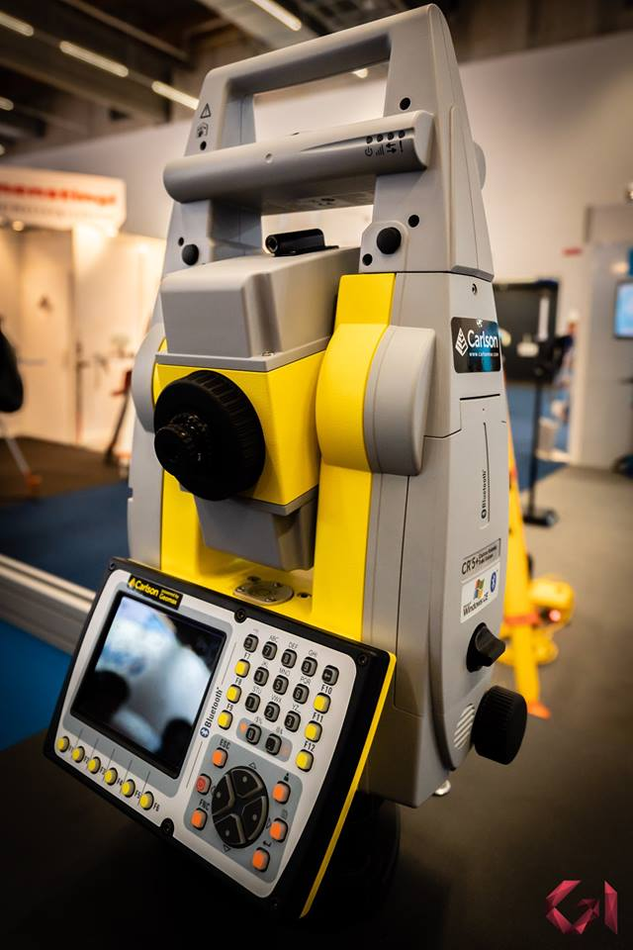
Fig. 1: Robotic total station

Tables
The tables should also be centered. The table description will be placed in front of the table and written in Arial, font size 10pt, bold, with 10pt blank space before and after. The description of the table will be labeled "Tab.".
Tab. 1: Working days
Column 1 | Column 2
Monday | 1
Tuesday | 2
Wednesday | 3
Thursday | 4
Friday | 5

Example of equation numbering
(1)

References
[1] Kudrna, J. Protismykové vlastnosti povrchů vozovek. Sborník ze semináře. VUT FAST, 2007
[2] Halásková, J. Evropské trendy k omezení dopravní nehodovosti. Sborník ze semináře. VUT FAST, 2007
[3] Viner, H., Sinhal, R., Parry, S. Review of UK Skid Resistance Policy. PIARC International Symposium „SURF2004“. Toronto, 2004
[4] Název webstránky, název organizace zodpovědné za webstránky [online, přístupné dne … ] dostupné na: www.policie.cz/web-informacni-servis-statistiky.aspx
[5] Vojtěšek, A. Srovnávací měření dynamických zařízení pro měření součinitele tření povrchu vozovek. Sborník ze semináře. VUT FAST, 2007

